Title: Band Together! (Wristbands)

Text:

We have created wristbands that serve a dual purpose: (1) promote bicycle safety, especially when cycling during evenings; and (2) remind us to live life fully. The wristbands will glow in the dark to keep our wearers visible in the dark and to remind us to stay safe while on the streets. The wristbands will also be debossed with the words “Live. Laugh. Love” -- the words that exemplify how Phyo chose to live each moment of his life.

If you would like to purchase a wristband, please Contact Us (link to the Contact Us page). We will be setting up an Amazon sales page soon to enable users to make online purchases also.

All funds raised will go towards the nonprofit activities of our Foundation. In particular, these funds will be used for the scholarships and educational initiatives for our local Boston students (link to Amphibious Achievement section) and Burmese children we are working to help (link to Giving Back to Burma section).

Photos for this Section:

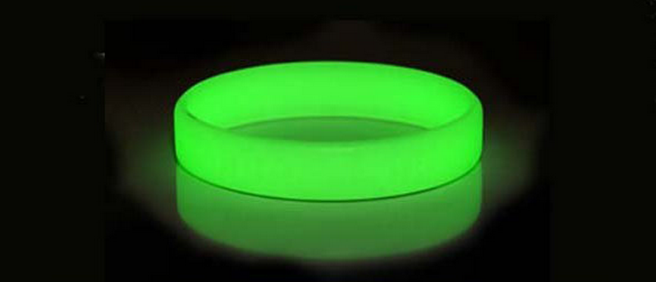

\*Courtesy of Google Images. The above image is not a sample item of the wristband we will be selling. We will post photos of the actual wristband as soon as we can after receiving them.

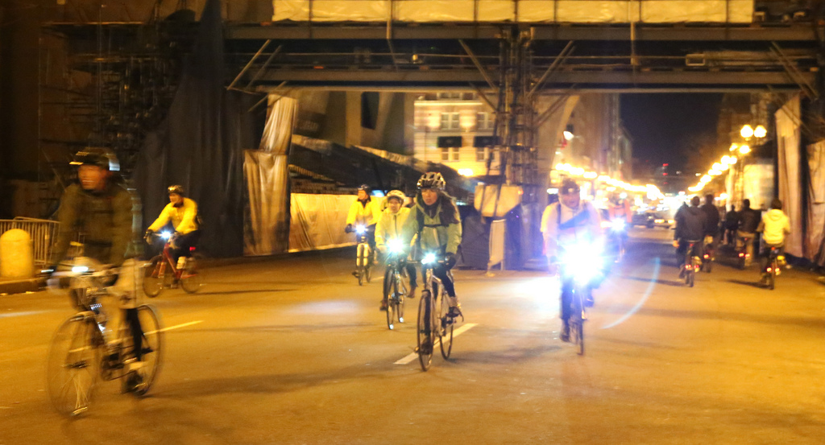

\*Additional comments:

Ye: I set up the amazon account page using our Gmail account. Once the wristband negotiations are settled, we can order, post photos, and start selling with this Amazon account.

// when we get the actual wristband, we should use actual example photos from our wristband. Source for the above image is here: <http://www.gophoto.it/view.php?i=http://image.made-in-china.com/2f0j00YekaKprzgBbM/Glow-in-The-Dark-Silicone-Wristband.jpg> and here: <http://ruilan.en.made-in-china.com/product/BqomhWnbreks/China-Glow-in-The-Dark-Silicone-Wristband.html>